**ĐẠI HỌC DUY TÂN**

**TRƯỜNG KHOA HỌC MÁY TÍNH**

**KHOA CÔNG NGHỆ PHẦN MỀM**

## C:\Users\Administrator\Desktop\logoDT.gif

**SYSTEM INTEGRATION**

**CASE STUDY II - EXECUTIVE DASHBOARD**

**LECTURER : Nguyễn Minh Nhật**

**CLASS : SE 445 C**

**GROUP : 5**

**MEMBER : Nguyễn Viết Quân**

**Bùi Trung Nguyên**

**Huỳnh Nhân**

**Nguyễn Đăng Quốc Thịnh**

**Đặng Ngọc Hoàng Thái**

**Đà Nẵng, 09/ 10/ 2024**

Contents

1

I .Purpose 3

**II.Requirement** 3

**III.Solution** 5

3.1 Solution 1: Create a New Database 5

3.2 Solution 2: Presentation Integration (Web Dashboard) 5

3.3. Choice and Rationale 6

**IV. Design model and use case** 7

*Form:Sign Up* 7

*Form: Login* 8

*Form: Employees Tab* 9

*Form: Earning Tab* 10

*Form: Day off Tab* 11

*Form: Benefits Tab* 12

*Form: Detail Tab* 13

*Form: Hiring Anniversary Tab* 14

*Form: Exceeding day off Tab* 15

*Form: Benefits Tab* 16

*Form: Birthday Tab* 17

# I .Purpose

The purpose of this project is to develop a comprehensive dashboard tailored for senior managers, providing them with summary information on employees, payroll, and benefits.

* Develop an integrated executive dashboard using the presentation-style integration approach.
* Develop requirements based on the CEO's memo, which will serve as the foundation for software development.
* Develop a test plan to thoroughly test the integrated dashboard.
* Create a feasible approach and schedule to ensure a high-quality product.
* Display the total earnings of employees, categorized by shareholder status and gender, for the current year and the previous year, segmented by department.
* Show the total number of vacation days taken by employees, categorized by shareholder status, gender, and employment type for the current and previous year.
* Present the average benefits paid to shareholders and non-shareholders to date, categorized by benefits plan.

**II.Requirement**

**Comprehensive Summary**: The dashboard will provide an overview of employee information, including details on payroll, benefits, and vacation days. This summary will be accessible to both the CEO and senior management.

**Alert System**: The dashboard will feature an alert system to notify management of specific conditions or special events, such as employment anniversaries, birthdays, or changes in employee status.

**Drill-Down Capability**: Senior managers will be able to explore the summary information in depth. They can access detailed data behind the summary for more comprehensive insights.

**Global View**: The dashboard will offer an overarching view of the entire company, including all its brands across different countries. This will enable the CEO to have a comprehensive understanding of ACME Company's global operations.

**CEO Detail Requirements**:

* **Employee Earnings Analysis**: The dashboard will provide a breakdown of total earnings by employee type (shareholder vs. non-shareholder), gender, ethnicity, and employment status (part-time vs. full-time) for both the current period and the previous year.
* **Vacation Days Tracking**: The dashboard will track and report the total number of vacation days taken by employees, categorized by shareholder status, gender, ethnicity, and employment type (part-time vs. full-time) for the current period and the previous year.
* **Benefits Cost Analysis**: The dashboard will calculate and present the average benefits paid to both shareholders and non-shareholders, categorized by benefits plan.
* **Employee Milestones Notification**: The dashboard will generate notifications when an employee is nearing their hiring anniversary, allowing management to recognize and celebrate these milestones.
* **Vacation Accumulation Alert**: The dashboard will alert employees who have accumulated more than a specified number of vacation days.
* **Benefits Plan Changes Impact Alert**: The dashboard will notify management when employees make changes to their benefits plans that affect payroll.
* **Birthday Celebration Reminder**: The dashboard will provide a list of employees with birthdays in the current month, facilitating recognition and celebration efforts.

**III.Solution**

## Solution 1: Create a New Database

***Benefits:***

* + - * Centralized Repository: Simplifies management and access.
      * Data Consistency and Quality: Ensures consistent data formats and validation.
      * Custom Optimization: Optimized data structures for organizational needs.
      * Advanced Reporting and Analytics: Easier implementation of comprehensive tools.
      * Scalability: Designed for future growth.

***Limitations:***

* + Development Overhead: Requires significant resources.
  + Data Synchronization Complexity: Introduces complexity and potential issues.
  + Potential Downtime: Transition may impact operations.
  + CEO's Access Requirement: May conflict with direct access needs.
  + Training: Requires training for effective use.

## 3.2 Solution 2: Presentation Integration (Web Dashboard)

***Benefits:***

* + Leverages Existing Systems: Reduces need for data migration.
  + Implementation: Quicker to develop and deploy.
  + Cost-Effective: Lower development and maintenance costs.
  + Web Accessibility: Accessible from anywhere with internet.
  + CEO Alignment: Meets CEO's requirement for integrated data view.
  + : Easier updates and modifications.

***Limitations:***

* Reliance on Existing Systems: Depends on maintenance of multiple systems.
* Security Concerns: Needs robust security measures.
* Integration Challenges: Difficulties in creating a cohesive dashboard.
* Performance Issues: Potential bottlenecks if systems are not optimized.
* Limited Customization: May have less flexibility in data structure optimization compared to a custom-built database.

## 3.3. Choice and Rationale

Solution 2 was chosen because it satisfies the CEO's requirements while leveraging existing infrastructure and offering a cost-effective and accessible solution.

**IV. Design model and use case**

## *Form:Sign Up*

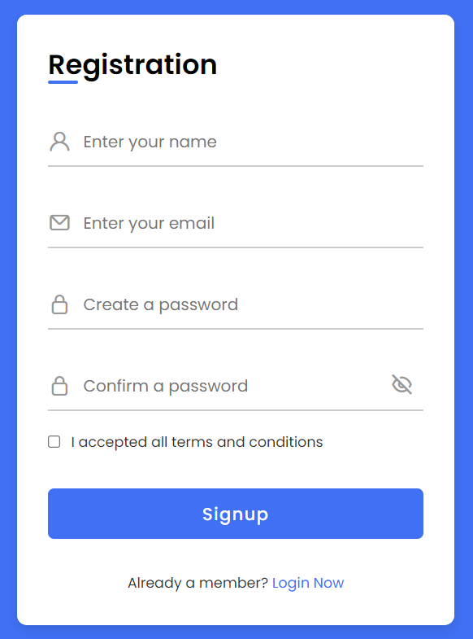

|  |  |  |
| --- | --- | --- |
| Module: Case Study II Form: CEO  Create by: Group 5 Create day: 09/10/2024 | | |
| Input: Form Login | | Output: Dashboard |
| Processing | Step by step |  |
| 1. Enter Username 2. Enter Email 3. Enter Password 4. Enter Confirm Password 5. Tick “I agree” 6. Click Create account to register an account and enter the login interface | | |

## *Form: Login*

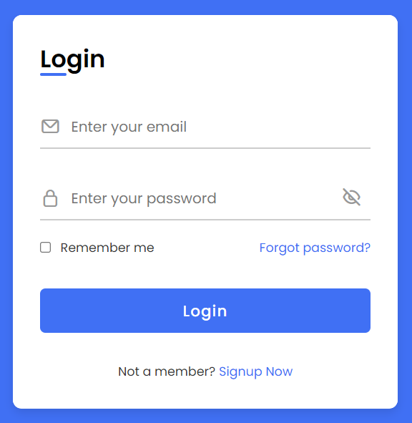

|  |  |  |
| --- | --- | --- |
| Module: Case Study II Form: CEO  Create by: Group 5 Create day: 09/10/2024 | | |
| Input: Form Login | | Output: Dashboard |
| Processing | Step by step |  |
| 1. Enter Username 2. Enter Password 3. Press Submit to go to Dashboard interface | | |

## *Form:* *Employees Tab*

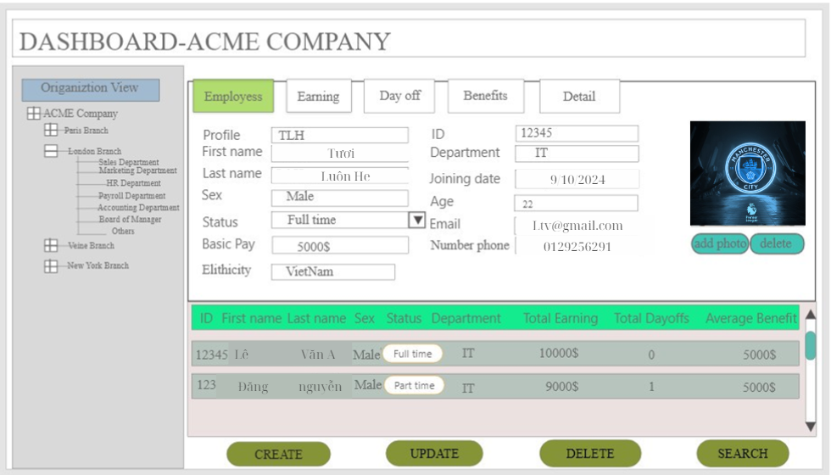

|  |  |  |
| --- | --- | --- |
| Module: Case Study II Form: CEO  Create by: Group 05 Create day: 09/10/2024 | | |
| Input: Form Employees | | Output: Dashboard |
| Processing | Step by step |  |
| 1. The employees information table is displayed at the bottom of the dashboard 2. Enter or select the information for employees in the form above. 3. Click the Created button to add employees information to the table. 4. Click the updated button to save employees information to the table. 5. Click the delete button to delete employees information from the table. 6. Click the search button to delete employees information from the table. | | |

## *Form:* *Earning Tab*

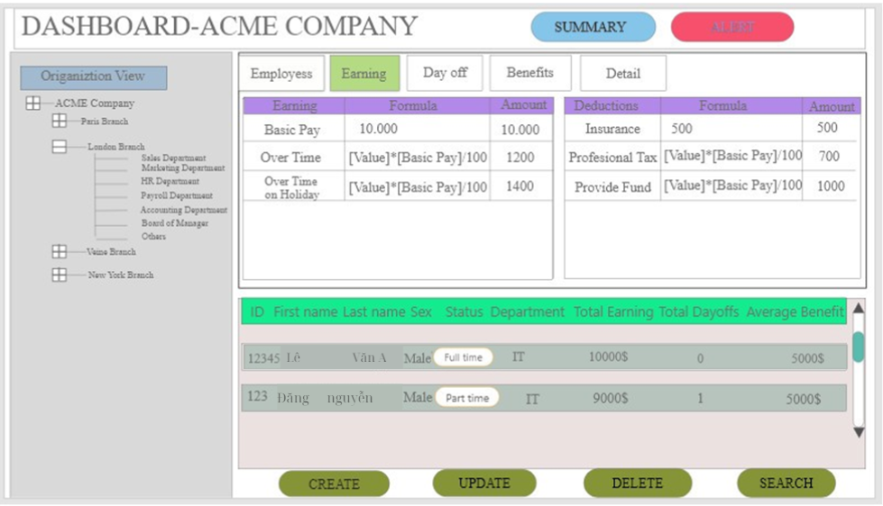

|  |  |  |
| --- | --- | --- |
| Module: Case Study II Form: CEO  Create by: Group 05 Create day: 09/10/2024 | | |
| Input: Form Earning | | Output: Dashboard |
| Processing | Step by step |  |
| 1. Follow the steps in Summary Tabs use case 2. Choose Form Earning 3. Choose Month and Year 4. See earning detail information of employee. 5. Click the Created button to add employees information to the table. 6. Click the updated button to save employees information to the table. 7. Click the delete button to delete employees information from the table. 8. Click the search button to delete employees information from the table. | | |

## *Form:* *Day off Tab*

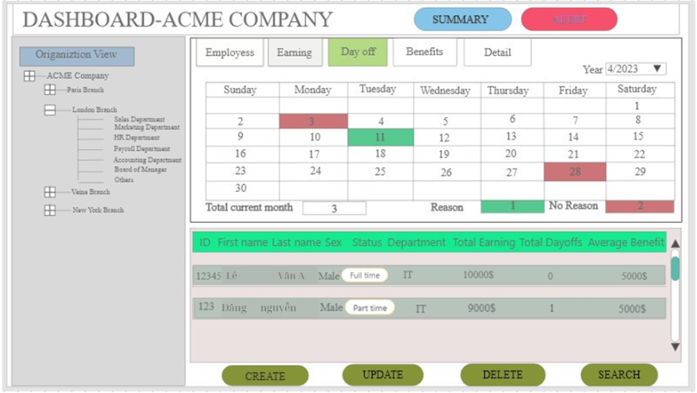

|  |  |  |
| --- | --- | --- |
| Module: Case Study II Form: CEO  Create by: Group 05 Create day: 09/10/2024 | | |
| Input: Form Day off | | Output: Dashboard |
| Processing | Step by step |  |
| 1. Follow the steps in Summary Tabs use case 2. Choose Form Day off 3. Choose Year 4. See day off detail information of employee. 5. Click the Created button to add employees information to the table. 6. Click the updated button to save employees information to the table. 7. Click the delete button to delete employees information from the table. 8. Click the search button to delete employees information from the table. | | |

## *Form:* *Benefits Tab*

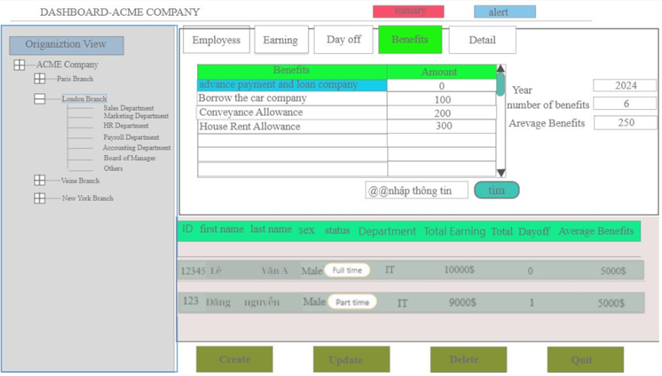

|  |  |  |
| --- | --- | --- |
| Module: Case Study II Form: CEO  Create by: Group 05 Create day: 09/10/2024 | | |
| Input: Form Benefit | | Output: Dashboard |
| Processing | Step by step |  |
| 1. Follow the steps in Summary Tabs use case 2. Choose Form Benefit 3. Choose Year 4. See benefit detail information of employee. 5. Click the Created button to add employees information to the table. 6. Click the updated button to save employees information to the table. 7. Click the delete button to delete employees information from the table. 8. Click the search button to delete employees information from the table | | |

## *Form:* *Detail Tab*

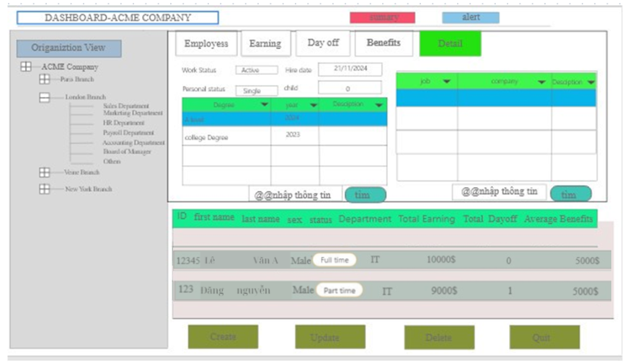

|  |  |  |
| --- | --- | --- |
| Module: Case Study II Form: CEO  Create by: Group 05 Create day: 09/10/2024 | | |
| Input: Form Detail | | Output: Dashboard |
| Processing | Step by step |  |
| 1. Follow the steps in Summary Tabs use case 2. Choose Form Detail 3. See detail information of employee. 4. Click the Created button to add employees information to the table. 5. Click the updated button to save employees information to the table. 6. Click the delete button to delete employees information from the table. 7. Click the search button to delete employees information from the table | | |

## *Form:* *Hiring Anniversary Tab*

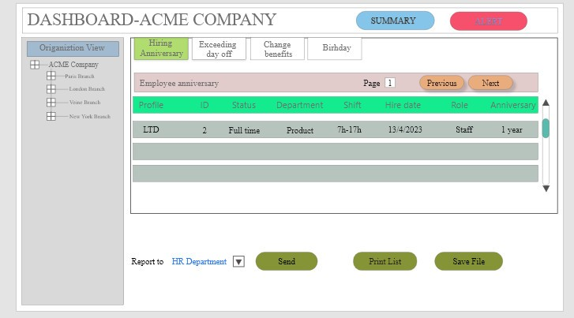

|  |  |  |
| --- | --- | --- |
| Module: Case Study II Form: CEO  Create by: Group 05 Create day: 09/10/2024 | | |
| Input: Form Hiring Anniversary | | Output: Dashboard |
| Processing | Step by step |  |
| 1. Choose Form Hiring Anniversary 2. See Hiring Anniversary information of employee | | |

## *Form:* *Exceeding day off Tab*

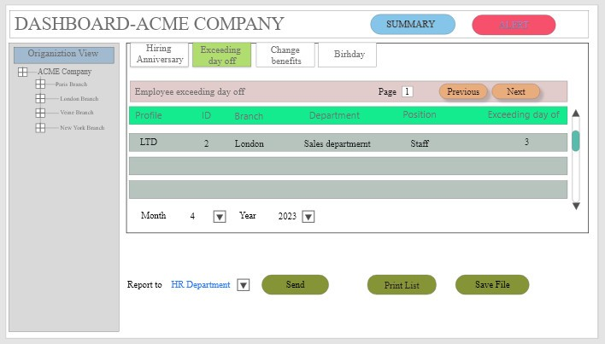

|  |  |  |
| --- | --- | --- |
| Module: Case Study II Form: CEO  Create by: Group 05 Create day: 09/10/2024 | | |
| Input: Form Exceeding Day Off | | Output: Dashboard |
| Processing | Step by step |  |
| 1. Choose Form Exceeding day off 2. View a list of employees who have exceeded their days off | | |

## *Form:* *Change Benefits Tab*

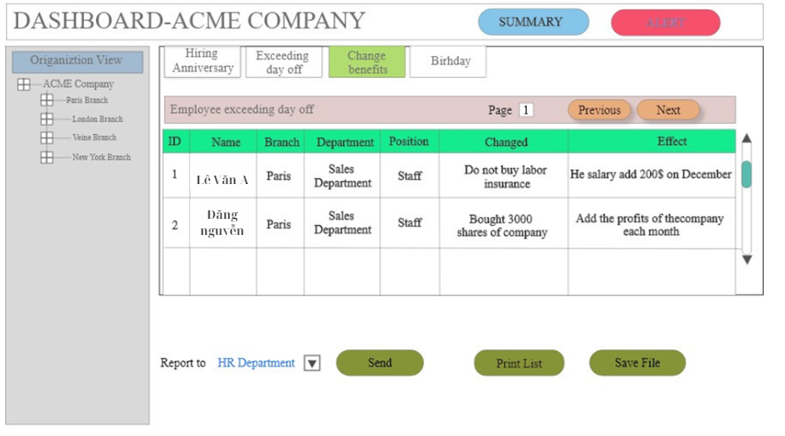

|  |  |  |
| --- | --- | --- |
| Module: Case Study II Form: CEO  Create by: Group 05 Create day: 09/10/2024 | | |
| Input: Form Change Benefits | | Output: Dashboard |
| Processing | Step by step |  |
| 1. Choose Form Change Benefits 2. View information about employee benefits | | |

## *Form:* *Birthday Tab*

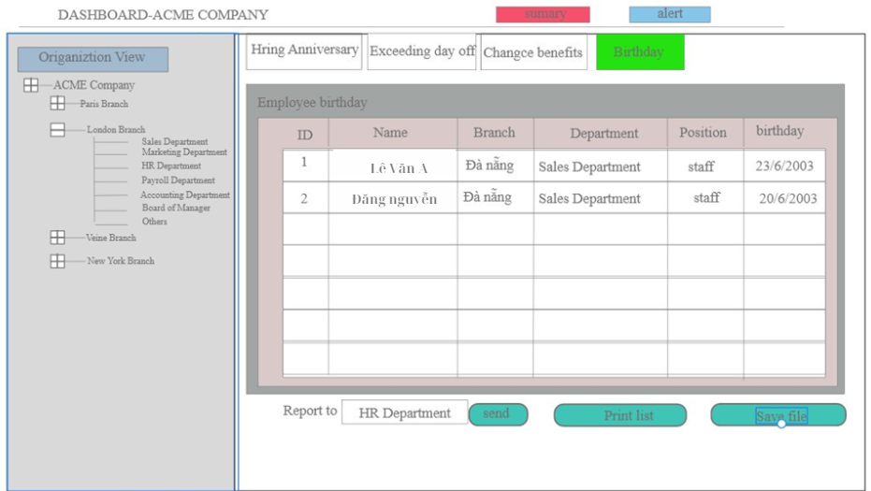

|  |  |  |
| --- | --- | --- |
| Module: Case Study II Form: CEO  Create by: Group 05 Create day: 09/10/2024 | | |
| Input: Form Birthday | | Output: Dashboard |
| Processing | Step by step |  |
| 1. Choose Form Birthday 2. View employee birthdays | | |